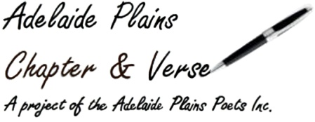
Gawler & Adelaide Plains
Festival of Words
2026
Booking Details

Name:__________________________________________________________
_______________________________________________________________
Contact Details:__________________________________________________
_______________________________________________________________
_______________________________________________________________
Method of Payment ie bank transfer, cheque, cash:_____________________
_______________________________________________________________
Banking Details
Account Name: Adelaide Plains Poets Inc
BSB 105-009
Acc 105 954 340

Or post to,
Adelaide Plains Poets
30 Germantown Road
Redbanks 5502 S.A.
**Please fill out the booking form below and email it to gawlerfestivalofwords@gmail.com
before doing the bank transfer or if sending cheque print out booking form and include it.
**Please note when paying by bank transfer put your name in the description dialogue box when submitting the payment so we know whom the payment is from.
Booking Form
Friday 24th July
Presentation
David Bailey On Planning and Environs
12.45 – 1.30 pm
$5.00
Saturday 25th July
Presentation
Self Publishing by Shelf Publishing
11.00-12.30 am
P/A Hotel, Murray St Gawler
$5.00
Workshop
Mike Ladd, Writing in and for the Environment
2.00 -3.30 pm @ the P/A Hotel, Gawler,

$30.00
$25.00 conc

Sunday 26th July
Workshop
Not Only Haiku; Japanese Short Forms
11.30 am-1.00 pm @ the P/A Hotel Gawler
$30.00
conc $25.00

