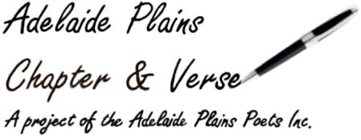
Gawler & Adelaide Plains
Festival of Words
2025
Booking Details

Name:__________________________________________________________
_______________________________________________________________
Contact Details:__________________________________________________
_______________________________________________________________
_______________________________________________________________
Method of Payment ie bank transfer, cheque, cash:_____________________
_______________________________________________________________
Banking Details
Account Name: Adelaide Plains Poets Inc
BSB 105-009
Acc 105 954 340

Or post to,
Adelaide Plains Poets
30 Germantown Road
Redbanks 5502 S.A.
**Please fill out the booking form below and email it to gawlerfestivalofwords@gmail.com
before doing the bank transfer or if sending cheque print out booking form and include it.
**Please note when paying by bank transfer put your name in the description dialogue box when submitting the payment so we know whom the payment is from.
Booking Form
Friday
Museum Visit & Writing Session. ($5.00 payable to Museum)
Saturday
Workshop One. Telling our History 10.00-11.00 @ the Gawler Culture and Heritage Centre, Gawler Civic Centre
Workshop Two Michelle Prak, Against the Clock: 2.00 -3.30 pm @ the P/A Hotel, Gawler,

$30.00
$25.00 conc
Workshop Three. Pitch a Story. 3.45 – 4.30 pm
$10.00
Sunday
Workshop
Ekphrastic Poetry 10.00 – 10.45 am Gather at Gawler Community Gallery, Lyndoch Road. 10.45-11.35 am Poetry Session @ the P/A Hotel Gawler
$10.00

