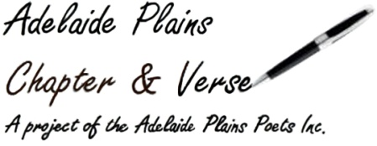

**Gawler & Adelaide Plains**

**Festival of Words**

**2021**

Booking Details

Name:__________________________________________________________

_______________________________________________________________

Contact Details:__________________________________________________

_______________________________________________________________

_______________________________________________________________

Method of Payment ie bank transfer, cheque, cash:_____________________

_______________________________________________________________

**Banking Details**  
Account Name: Adelaide Plains Poets Inc

BSB 105-009

Acc 105 954 340

Or post to,

Adelaide Plains Poets

30 Germantown Road

Redbanks 5502 S.A.

**Please fill out the booking form below and email it to [gawlerfestivalofwords@gmail.com](mailto:gawlerfestivalofwords@gmail.com)

before doing the bank transfer or if sending cheque print out booking form and include it.

**Please note when paying by bank transfer put your name in the description dialogue box when submitting the payment so we know whom the payment is from.

**Booking Form**

**Friday**

**Poetry Slam**

$1$5.00

**Saturday**

**Workshop One**

Allayne Webster, Writing for Young People

Gawler Library Gawler Civic Centre. (Bookings can be made either by phoning the library on 8522 9213 or online through Eventbrite at <https://www.eventbrite.com.au/e/157750821955> )

**Workshop Two**

Sharon Kernot, “Long Verse” @Langmeil Church Tanunda

$30.00

$25.00 conc

**Workshop Three**

Rebecca Sullivan, A journey to Publication @Recreate, Mt Pleasant

$30.00

$25.00 conc

For Both Workshops

$50.00

$45.00 conc